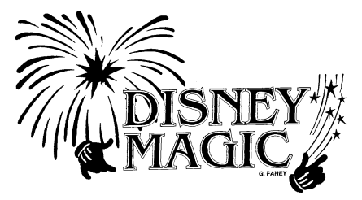

September 23, 2013
Dear Families,
The Response to Intervention letter attached is to confirm the program that has been built for your child this school year. Disney has been providing the services throughout the year as needed to meet the learning needs of your child. The purpose of the letter is to highlight the acceleration plan for students in our building in the areas of reading, writing, mathematics or behavior.
Our Disney Staff will continue to review the progress of your child and update the program for your child throughout the year.
If you have any questions or concerns please feel free to contact your child’s teacher or me at any time. Your child’s success is the priority of Disney Elementary.
Sincerely,
Aaron Sutherland
Principal, Disney Elementary
Aaron.Sutherland@FraserK12.org
586.439.6495

